Assignment-1

|  |  |
| --- | --- |
| Assignment Date | 19 November2022 |
| Student Name | A.varsha |
| Student Roll No | 814419106005 |
| Maximum Marks | 2 Marks |

Smart Home:

Circuit:

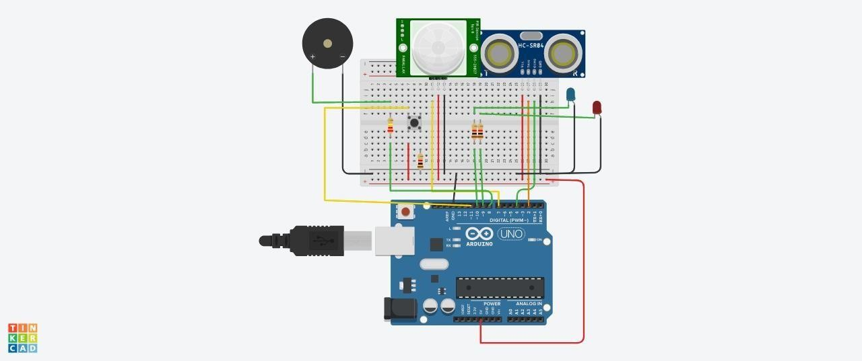

Components:

|  |  |
| --- | --- |
| **Components** | **Quantity** |
| Push Button | 1 |
| Red LED | 1 |
| Blue LED | 1 |
| PIEZO Buzzer | 1 |
| Ultrasonic Distance Sensor | 1 |
| PIR Sensor | 2 |
| Resistor (220,560,10K) | 2 |
| Arduino R3 | 1 |
| Breadboard Small | 1 |

Code:

const int trigPin = 2;

const int echoPin = 4;

const int pirPin = 7; int pirState = LOW;

const int buzzerPin = 8; const int redLED = 9;

int redBright = 0; int redFade = 5;

const int greenLED = 10;

int greenBright = 0;

int greenFade = 5; const int button = 13;

void setup() {

pinMode(echoPin, INPUT); pinMode(pirPin, INPUT); pinMode(button, INPUT); pinMode(trigPin,OUTPUT); pinMode(redLED, OUTPUT); pinMode(greenLED, OUTPUT); pinMode(buzzerPin, OUTPUT);

Serial.begin(9600);

}

void distance()

long durationInDigit; long distanceInInches;

digitalWrite (trigPin, LOW); delayMicroseconds(2); digitalWrite (trigPin, HIGH); delayMicroseconds(10);

digitalWrite (trigPin, LOW); durationInDigit = pulseIn(echoPin, HIGH); distanceInInches = durationInDigit/74/2;

Serial.println(distanceInInches);

if (distanceInInches > 15 && distanceInInches < 30) { digitalWrite(greenLED, HIGH); digitalWrite(redLED, LOW);

}

if (distanceInInches < 10) { digitalWrite(redLED, HIGH); digitalWrite(greenLED, LOW);

}

if (distanceInInches > 10 && distanceInInches < 15){ digitalWrite(redLED, LOW); digitalWrite(greenLED, LOW);

}

if (distanceInInches < 5) { digitalWrite(redLED, HIGH); tone(8, 250, 2000);

digitalWrite(greenLED, 0);

}

if (distanceInInches > 5 && distanceInInches < 10){ digitalWrite(redLED, HIGH); digitalWrite(buzzerPin, 0);

digitalWrite(greenLED, 0);

if (distanceInInches > 30 || distanceInInches < 0){ Serial.println("Distance Incalculable");

}

delay(500);

}

void reset() {

if (digitalRead(button), HIGH); digitalWrite(pirState, LOW); digitalWrite(redLED, LOW); digitalWrite(greenLED, HIGH); digitalWrite(buzzerPin, 0);

//digitalWrite(echoPin, 0);

}

void loop() {

distance();

int pirState = digitalRead(pirPin);

if (pirState==1) { Serial.println("Motion Detected!!!"); digitalWrite(greenLED, LOW); digitalWrite(redLED, HIGH); digitalWrite(buzzerPin, 1); delay(500);

if (pirState==0) { Serial.println("Detecting...");

digitalWrite(greenLED, HIGH); digitalWrite(redLED, LOW); digitalWrite(buzzerPin, 0); delay(500);

}

}